**Topic: Smart tripod for taking photos**

**1.Introduction:**

This system, with a camera, will automatically adjust its position or orientation after setup, and then take a beautiful picture of the user.

It shall try to fit the user into some expected screen (pre-input).

**2.Features:**

- Auto adjust position and orientation.

- Trace the user’s position

- Adjust position according to user’s expectation input (say it will try to match the background with some user’s input image)

**3.Device:**

3.1 垂直导轨搭载

3.1.1

<http://item.taobao.com/item.htm?spm=a230r.1.14.290.FOD6zy&id=38212110616&_u=f85urvt4688>

3.1.2

<http://item.taobao.com/item.htm?spm=a230r.1.0.0.G7LeoV&id=37740365921>

3.1.3

伸缩

3.2 底座

<http://item.taobao.com/item.htm?spm=a230r.1.14.108.B3h9JU&id=17546939648>

<http://item.taobao.com/item.htm?spm=2013.1.0.0.1tPVoI&scm=1007.10009.518.0&id=36888160535&pvid=1eb03acd-df40-46c9-9dc9-6bcddf3cf735>

<http://item.taobao.com/item.htm?spm=a230r.1.14.114.pEbUxJ&id=25435444255&_u=f85urvtbac6>

3.3 摄像头

3.3.1 **航拍攝像頭** <http://item.taobao.com/item.htm?spm=a230r.1.14.11.FarYbB&id=21969563780&_u=f85urvt3dce>

3.3.2

<http://www.cmucam.org/>

3.3.3

<http://item.taobao.com/item.htm?id=17800586077>

**4.Stages:**

Stage 1:

- Design and build a motion system that can move.

- Design State Machine for Motion System

- Build Control System Prototype

- Learn to use API for camera module. (OpenCV or something)

- Capture the picture from the camera

移动: 自旋

Stage 2:

- Combine the components

- Detect human to be photoed(may need distance sensor)

- Calculate the center of the human area

Stage 3:

- photo comparison /

- movement decision

Stage 4:

- Let the camera robot adjust its position and orientation if the user decided to change his position a little bit from the original position.

Stage 5:

- Let the camera robot automatically adjust position and orientation according to the user input’s reference photo.

Stage 6:

- Refinement, perfect the system, make sure no bugs and no ‘accident’ will happen during demo.

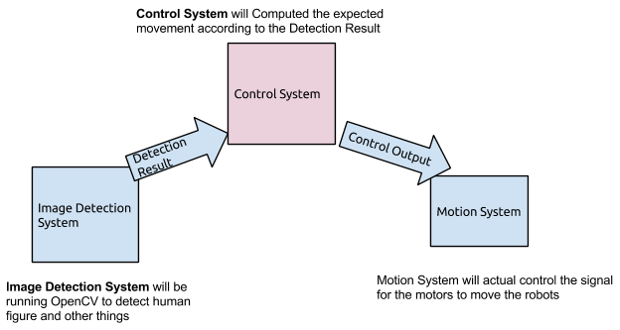

固定，俯仰自由度（1个）

距离检测

手机拍一张照片，然后往前走，机器自动拍

<http://www.teledynedalsa.com/imaging/products/cameras/programmable/icon/>

<https://www.youtube.com/watch?v=8QouvYMfmQo>

<http://fadz168.taobao.com/category-610092408.htm?spm=a1z10.5.w4010-4540523556.12.G2G2ak&search=y&catName=FPV%CE%DE%CF%DF%CD%BC%B4%AB%C6%F7#bd>

<http://blog.csdn.net/lhf_zj/article/details/6938900>